1. 7 Row vehicle
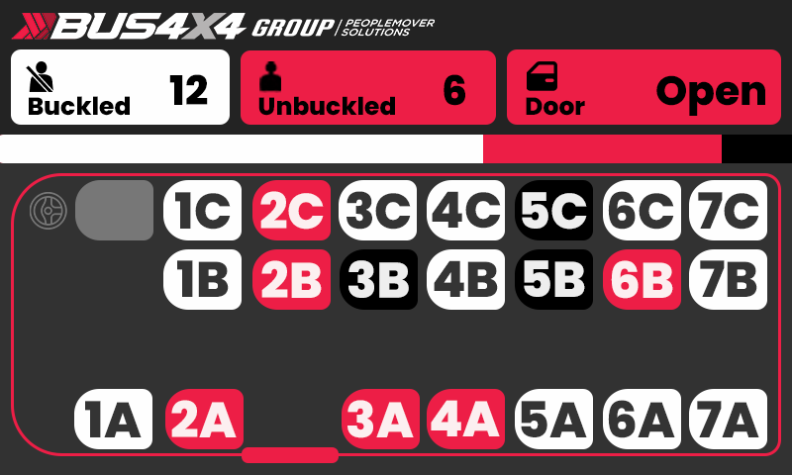

2. 7 Row vehicle with no last row (7th black box not plugged in)
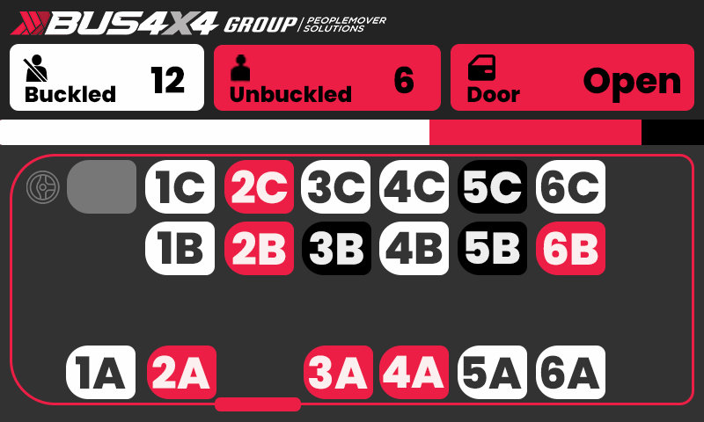

3. 4 Row vehicle
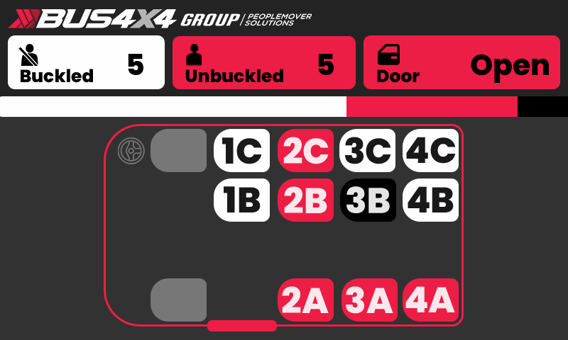

4. 4 Row vehicle with seat not plugged in
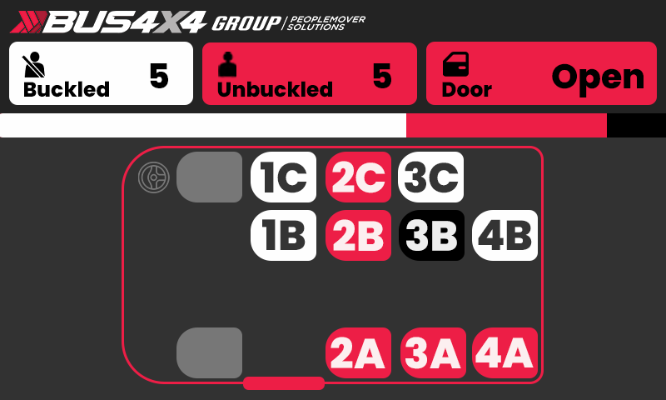

5. Left hand drive - everything is inverted (door, driver seat, seats a/b/c/d)
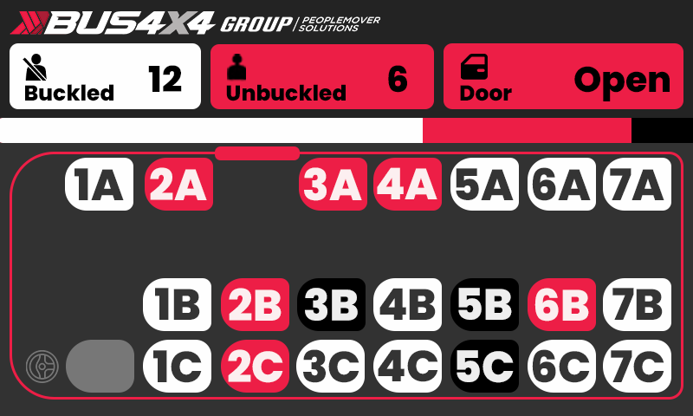

6. 4 seats in a single row (7A,7B,7C,7D)
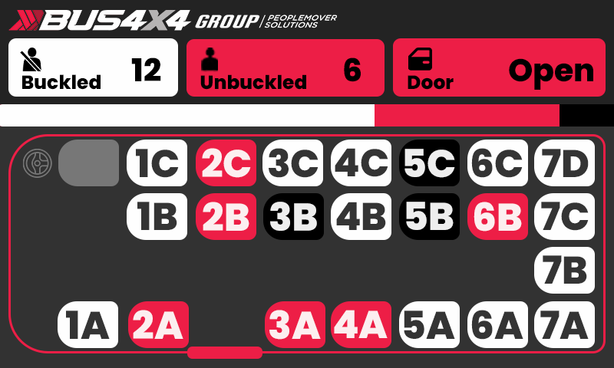

Colours:
- Red: Unbuckled or door open
- White: Buckled or door closed
- Black: Idle chair - seat/buckle sensors plugged in but no one is sitting in the chair
- Door: Red if door is open. White if door is closed.
- Vehicle outline: is red if any indicator (door, unbuckled) is red. Is white if everyone is buckled and the door is closed.
Features:
Data display:
- Buckled: number of buckled passengers
- Unbuckled: Number of unbuckled passengers
- Door: Door open/closed status
- Loading bar: Display % of buckled, unbuckled and idle chairs (seat/buckle sensors plugged in but no one is sitting in the chair).
Seats:
- If a seat (A/B/C/D seat/buckle sensor molex) is not plugged in, then that seat will not display (see 4. image)
Row:
- If a row (transmitter PCB [blackbox]) is not plugged in, then the entire row will not display (see 2. image).
Right hand drive:
- Inverted vehicle layout if right hand drive.
Vehicle Layouts
- 4 row vehicle:
  - Vehicle with 4 rows. Program displays a 4 row layout if less than 5 rows (transmitter modules plugged in) is true.
- 7 row vehicle:
  - Vehicle with 7 rows. Program displays a 7 row layout if greater than 4 rows (transmitter modules plugged in) is true.
- Right hand drive:
  - Displays right hand drive layout . Pre-programmed unless you can think of a way to automate detection.
- Left hand drive:
  - Displays left hand drive layout. Pre-programmed unless you can think of a way to automate detection.

